**4.4 Determining the Index of Refraction Experimentally** Name: __________________________

**Purpose:** 1) Measure the index of refraction of water

2) Determine the critical angle of water Score: _______ / 25

3) (optional) Measure the index of refraction of another liquid (e.g. oil)

**Materials:** Semicircular tray, laser pen, water, another fluid, paper, pencil, file card

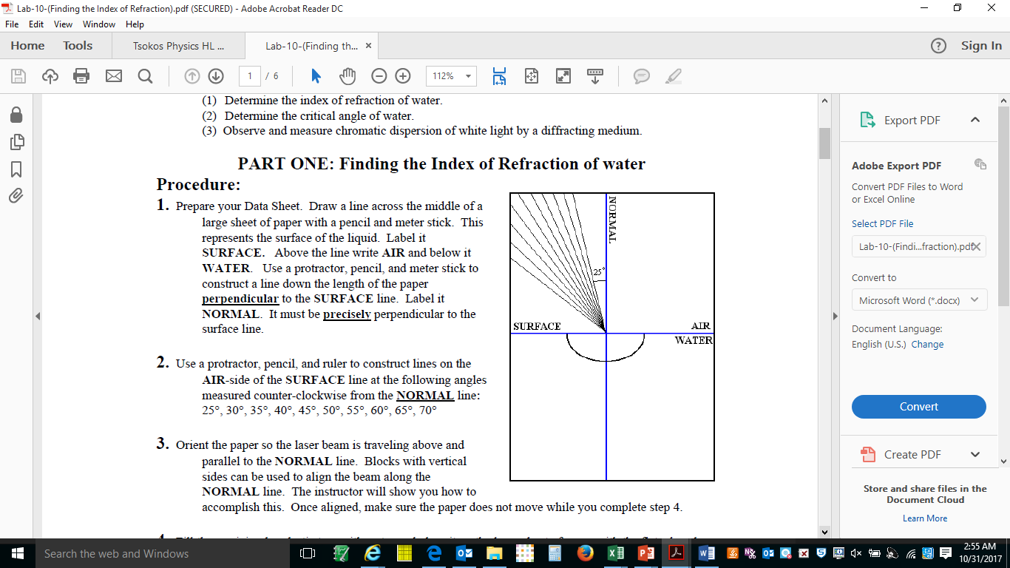**PART ONE: Measure the index of refraction of water**

**Procedure:**

1. Prepare your Refraction Sheet. Draw a line across the middle of a page with a pencil and a ruler. This represents the surface of the liquid. Label it SURFACE. Above the line write AIR and below it WATER. Use a protractor, pencil, and ruler to construct a line down the length of the paper **perpendicular** to the SURFACE line. Label it NORMAL. It must be **precisely** perpendicular to the SURFACE line. (Hint: Folding the paper into half both ways helps you with this.)

2. Use a protractor, pencil and ruler to construct lines on the AIR side of the SURFACE line at the following angles measured counter-clockwise from the NORMAL line: 25°, 30°, 35°, 40°, 45°, 50°, 55°, 60°, 65°, 70°.

3. Fill the semicircular plastic tray with water and place it on the Refraction sheet with the flat edge along and parallel to the SURFACE line. Make sure the water is on the “water” side of the SURFACE line.

4. Align the laser centered on and parallel to the 25° line so it hits the center of the flat side of the tray just above the NORMAL line.

5. Mark where the refracted beam exits the curved side of the tray with a mark on the paper labeled with the incident angle used. Repeat for each of the 10 incident angles.

6. Draw lines from the center of the paper to each mark made in step 5. Measure the angle to each line relative to the NORMAL to 0.1° and record in the data table for water.

**Calculations:**

1) Determine the sine of each angle and record in the data table.

2) Determine the index of refraction for water using your sine values, the index of refraction of air = 1.00029 and Snell’s law.

3) Determine the average nwater and standard deviation.

4) Determine the index of refraction for your laser if the index of refraction for water when you use a frequency of 5.09 x 1014 Hz is 1.33. **Show work here**:

5) Determine a percent error relative to the expected value for your laser wavelength for your average result.

6) Plot sin air  vs sin water.

7) Draw a best fit line and determine its slope.

8) Determine the index of reflection for water based on the slope of your graph and the index of refraction of air = 1.00029.

9) Determine a percent error relative to the expected value for your laser wavelength for your graph result.

**Modified from** http://faculty.trinityvalleyschool.org/hoseltom/labs/Lab-10-(Finding%20the%20Index%20of%20Refraction).pdf

**Data and Calculations Table for PART ONE**

Wavelength of laser: ___________________ Color of laser: ___________________

|  |  |  |  |  |
| --- | --- | --- | --- | --- |
| **incident = air** | **refracted = water** | **sin air** | **sin water** | **nwater** |
| 25.0° |  |  |  |  |
| 30.0° |  |  |  |  |
| 35.0° |  |  |  |  |
| 40.0° |  |  |  |  |
| 45.0° |  |  |  |  |
| 50.0° |  |  |  |  |
| 55.0° |  |  |  |  |
| 60.0° |  |  |  |  |
| 65.0° |  |  |  |  |
| 70.0° |  |  |  |  |

Average nwater = _____________________ Standard Deviation: ___________________

Expected index of refraction: ___________ Percent error: _______________________

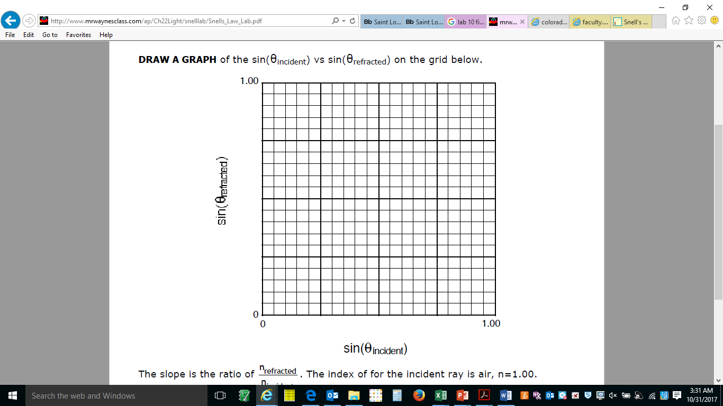

Slope of best fit line?

nwater  = _______________

Percent Error = _________

**Part 1 Questions:**

1) Express your measured average index of refraction for water with its uncertainty.

2) Does your measured index of refraction for water with its uncertainty include the expected value?

3) Which method of determining the index of refraction was most effective, finding averages or graphing?

4) Identify two sources of errors that may have contributed to your percent error for part 1.

**PART TWO: Determine the critical angle for water**

**Procedure:**

1. This time aim the laser beam in the water through the curved back wall of the tray. You are aligned correctly when the angle you can measure with the tray is the same for the incident ray and the reflected ray.

2. Rotate the laser until the refracted beam on the AIR side makes a 90 degree angle with the normal. Use a vertical file card to track the position of the refracted beam to help determine when this happens.

3. Read the angle of the incident ray from the bottom of the tray, which is relative to the surface by looking directly down. Record this angle in the space indicated below to 0.1°.

4. Measure 5 times using both sides of the curved part of the tray, alternating from side to side.

Measured angles to the surface: __________ __________ __________ __________ __________

**Calculations**:

Critical Angle (relative to normal): __________ __________ __________ __________ __________

Ave Critical Angle: _____________ Standard Deviation of Critical Angle: ____________

Determine the theoretical critical angle you’d expect between water and air using your nave  for water from part 1.

Determine a percent error for your average critical error. ________________

**Part 2 Questions:**

1) Express your measured average critical angle for water with its uncertainty.

2) Does your measured critical angle for water with its uncertainty include the expected value?

3) Identify two sources of errors that may have contributed to your percent error for part 2.

4) Compare your results with other groups. How do the results of this lab depend on the laser wavelength?

**PART THREE (Time permitting)** Repeat part 1 for another liquid of your choosing, preferably one that has a “known” index of refraction you could use for comparison of your results. Oils are the best kind of choice.

**Data and Calculations Table for PART THREE**

Wavelength of laser: ___________________ Color of laser: ___________________

|  |  |  |  |  |
| --- | --- | --- | --- | --- |
| **incident = air** | **refracted = water** | **sin air** | **sin water** | **nwater** |
| 25.0° |  |  |  |  |
| 30.0° |  |  |  |  |
| 35.0° |  |  |  |  |
| 40.0° |  |  |  |  |
| 45.0° |  |  |  |  |
| 50.0° |  |  |  |  |
| 55.0° |  |  |  |  |
| 60.0° |  |  |  |  |
| 65.0° |  |  |  |  |
| 70.0° |  |  |  |  |

Average nwater = _____________________ Standard Deviation: ___________________

Expected index of refraction: ___________ Percent error: _______________________



Slope of best fit line?

nwater  = _______________

Percent Error = _________